NTSAKO VALENTIAH BALOYI ASSIGNMENT 2 DEODABS
- What is the average, median, and count of total price?
1.Count of order ID=1200
2.Average of totalprice=1053,9683
3.Median=769,38

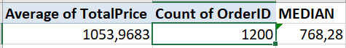
2. Question 2: What are the trends in OrderStatus?
Cancelled is the first trends,followed by returned and pending
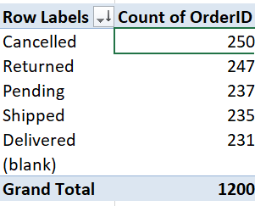
Question 3: Are there outliers in UnitPrice?
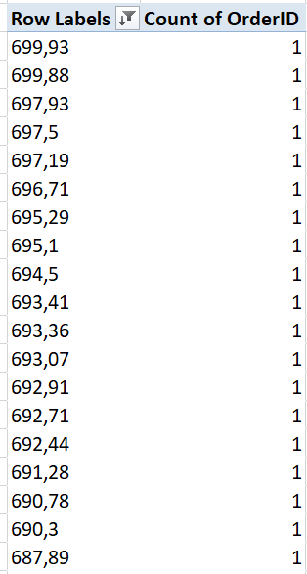
Question 4: Which products bring the most revenue?
Laptop followed by printer and chair

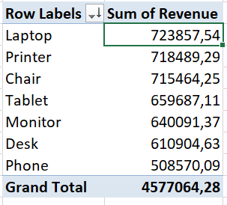
Question 5: Which referral source brings the most orders?
Instagram followed by email then google
